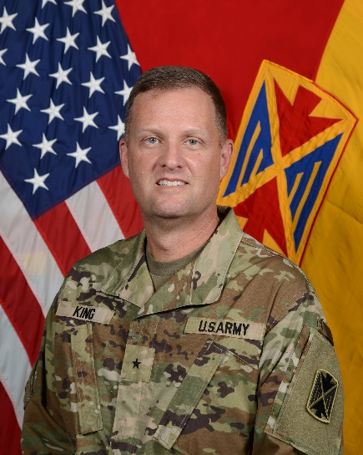

Brigadier General Curtis W. King
Brigadier General Curtis W. King is the Commanding General for 10th Army Air and Missile Defense Command. Prior to assuming this position, he served as the commandant of the U.S. Army Air Defense Artillery School, Chief of Air Defense Artillery, and Deputy Commanding General of the Fires Center of Excellence and Fort Sill, Oklahoma. Brigadier General King, a native of Central City, Kentucky, was commissioned from the United States Military Academy at West Point as an Air Defense Artillery Officer.
From 1997-1999, BG King’s served as a Platoon Leader and Battalion Fire Direction OIC in the 1st BN 7th Air Defense Artillery Regiment at Kaiserslautern, Germany and Fort Cavazos, Texas. From 2000 to 2002, he served as the Brigade Assistant S-3, in 108th Air Defense Artillery, Commander Alpha Battery, 3rd BN 6th Air Defense Artillery Regiment, Commander, Delta Battery, 1st BN 1st Air Defense Artillery Regiment, Fort Cavazos, Texas. In 2005 BG King served as the Missile Defense Planner, Joint Functional Component for Integrated Missile Defense at Peterson Air Force Base Colorado Springs, Colorado. From 2007 to 2009 he served as the Battalion Operations Officer, 3rd BN 4th Air Defense Artillery Regiment, and Brigade Operations Officer, 108th Air Defense Artillery Brigade, Fort Liberty, North Carolina.
In 2010, BG King was assigned as the Commander for Task Force Torkham, 1st BDE Combat Team, 101st AASLT Division in Nangarhar Province, Afghanistan. He also served as the Deputy Commander, 108th Air Defense Artillery Brigade, and as the Battalion Commander, 1st BN 7th Air Defense Battalion, Fort Liberty, North Carolina from 2011-2013.
In 2015, BG King was assigned to the Joint Special Access Program Office Chief, at the Pentagon. In 2017 BG King took command of the 69th Air Defense Artillery Brigade, Fort Cavazos, Texas. After relinquishing command, he served as Plans Director, FORSOM G3/5/7, Fort Liberty, North Carolina.
His military education includes the Air Defense Artillery Basic Officer Leader Course, Captain’s Career Course, Command and General Staff College, US Army War College, and Airborne School.
His awards and decorations include the Defense Superior Service Medal; Legion of Merit with 3 Oak Leaf Clusters; Bronze Star; Meritorious Service Medal with 4 Oak Leaf Clusters; Army Commendation Medal with 4 Oak Leaf Clusters; the Joint Service Achievement Medal; Parachutist Badge and the Joint Chiefs of Staff Identification Badge.

